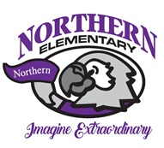

Northern Elementary

2024-2025

**2nd Grade Supply List**

* 3 Composition Books – Wide Ruled – Black
* Colored Pencils – Crayola – 12 Ct
* Folder – Plastic & Pocket - Purple
* Folder – Plastic & Pocket - Red
* Folder – Plastic & Pocket - Yellow
* Crayons – Crayola – 24 Ct – 2 boxes
* Expo Dry Erase Markers – Black – Fine – 8 Ct
* Elmers Washable Glue Sticks – 10+
* 24 Pencils – Sharpened – No 2
* Pencil Pouch – Clear – 3 Ring or Box
* Eraser – Papermate – Pink Pearl – Large – 1 Pk
* Scissors – Fiskar – Kids – 5 inch – Blunt
* Earbuds – Tangle Free Cord – or Headphones
* Tissues – Kleenex

Please label items with your child’s name

***Optional Items – Not required but appreciated***

* Paper – Cardstock – White
* White copy paper
* Disinfectant Wipes
* Ziploc Bags – Gallon
* Ziploc Bags – Sandwich

Please bring your child’s supplies to our Open House